Manage different environments and configurations for iOS project

1.0 Project Setup 1

1.1 Add Shema and Configurations: 1

1.2 Add Configurations Settings File: 3

1.3 Link build configuration with the configuration file: 5

1.4 Link schema with the build configuration: 5

1.5 Config app’s name for each environment: 7

1.6 Build and run project: 10

# Project Setup

We need to split our project into 3 different environments: **Dev, Stagging, Prod** and each environment has its own independent configuration file.

## Add Shema and Configurations:

Select the project in the **Project Navigator** pane then select **Info** from the two options (**Info and Build Settings**). In the **Configurations**, we have to add our own configuration with these following 3 environments **(Dev, Stagging, Prod)**.

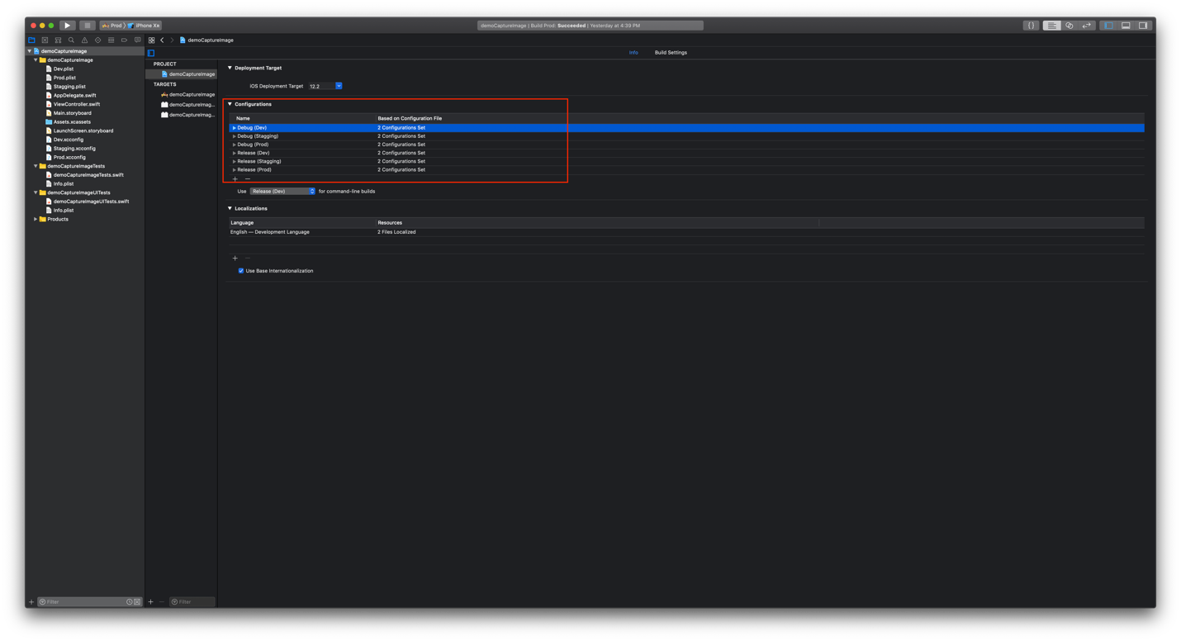

For **shema creation**, go to **manage shema** in top left corner of Xcode > Rename or delete the existing shema and add a new one with the name same as our environment’s name.

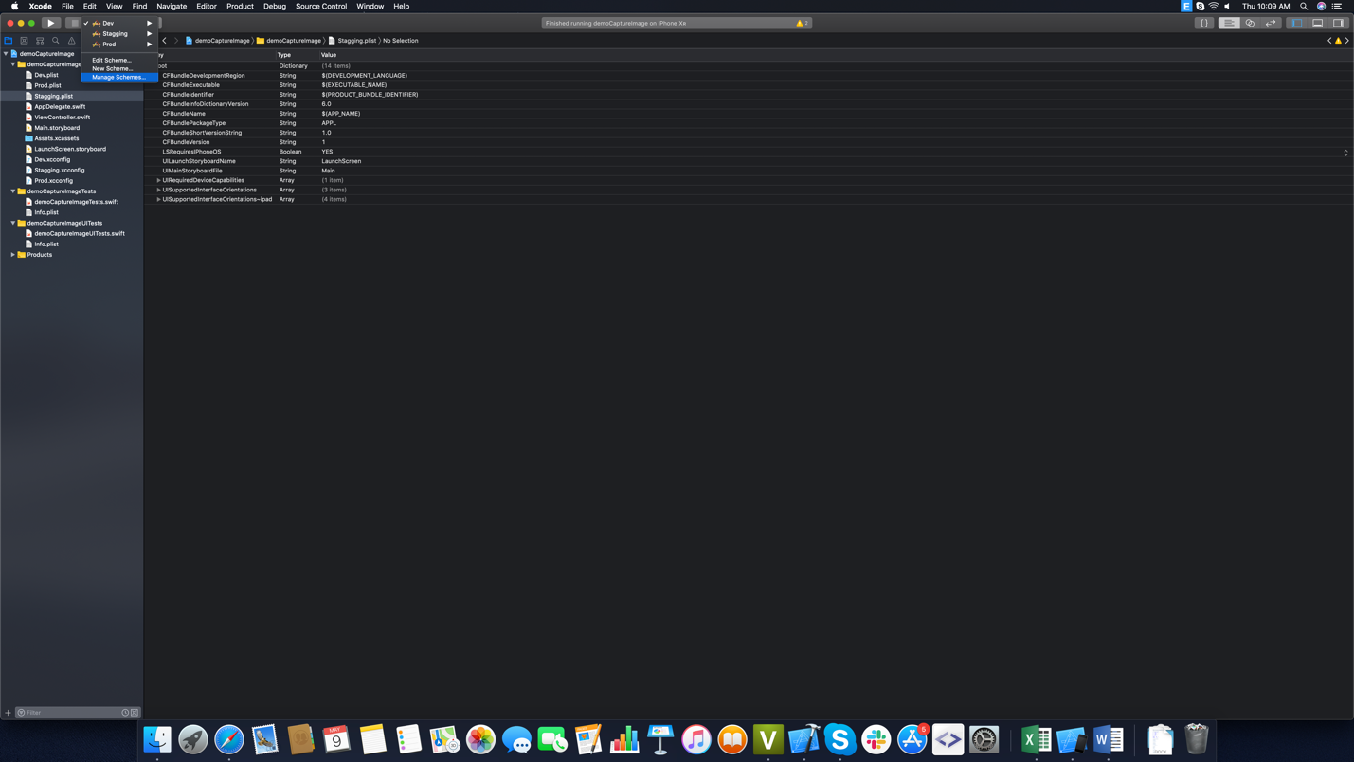

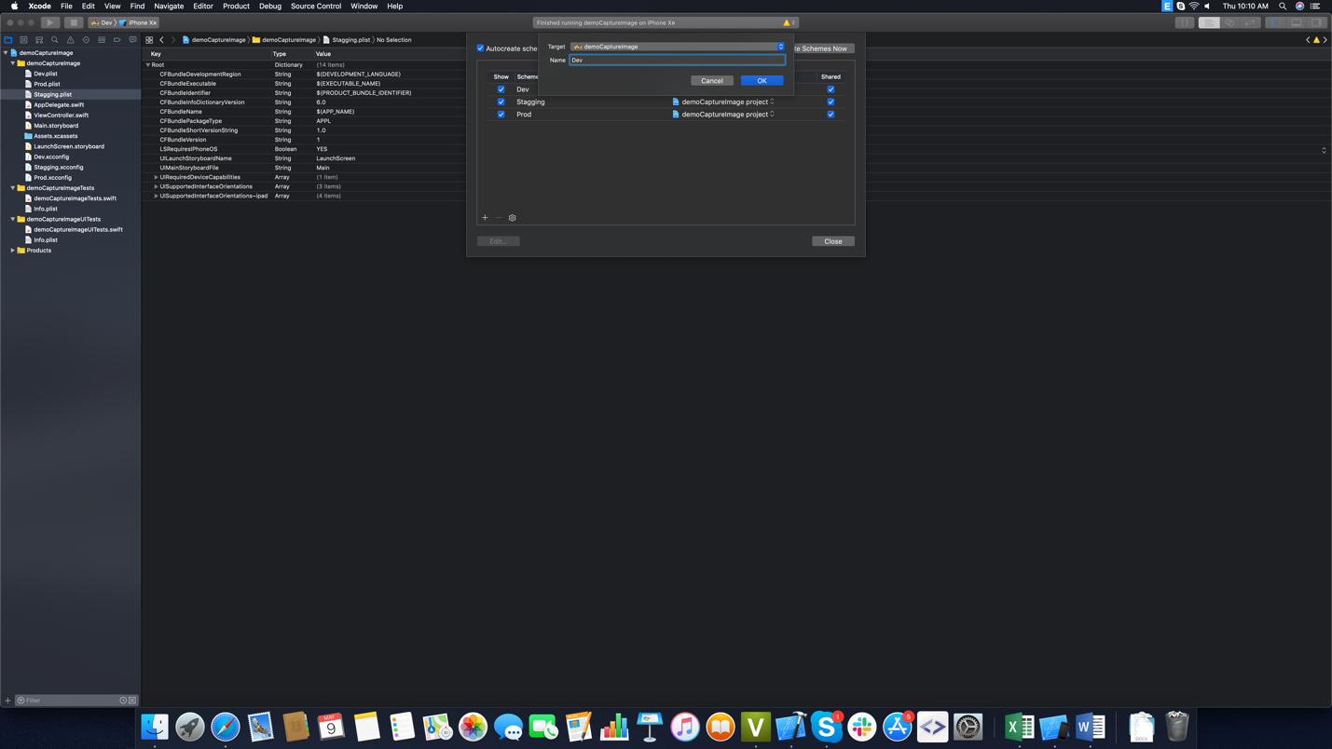

## Add Configurations Settings File:

Right click on **Project folder > Select new file > Add Configurations Settings File** then give it the same name as each environment’s name **(Dev, Stagging, Prod)**.

After that our project should looks like this:

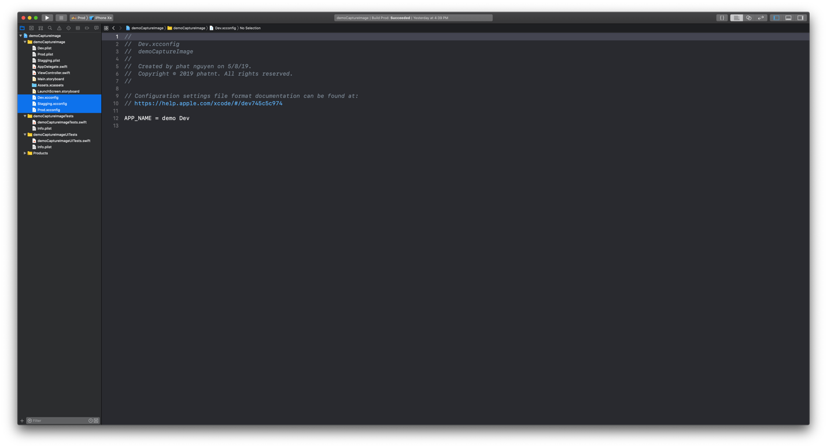

Then our project should looks like this:

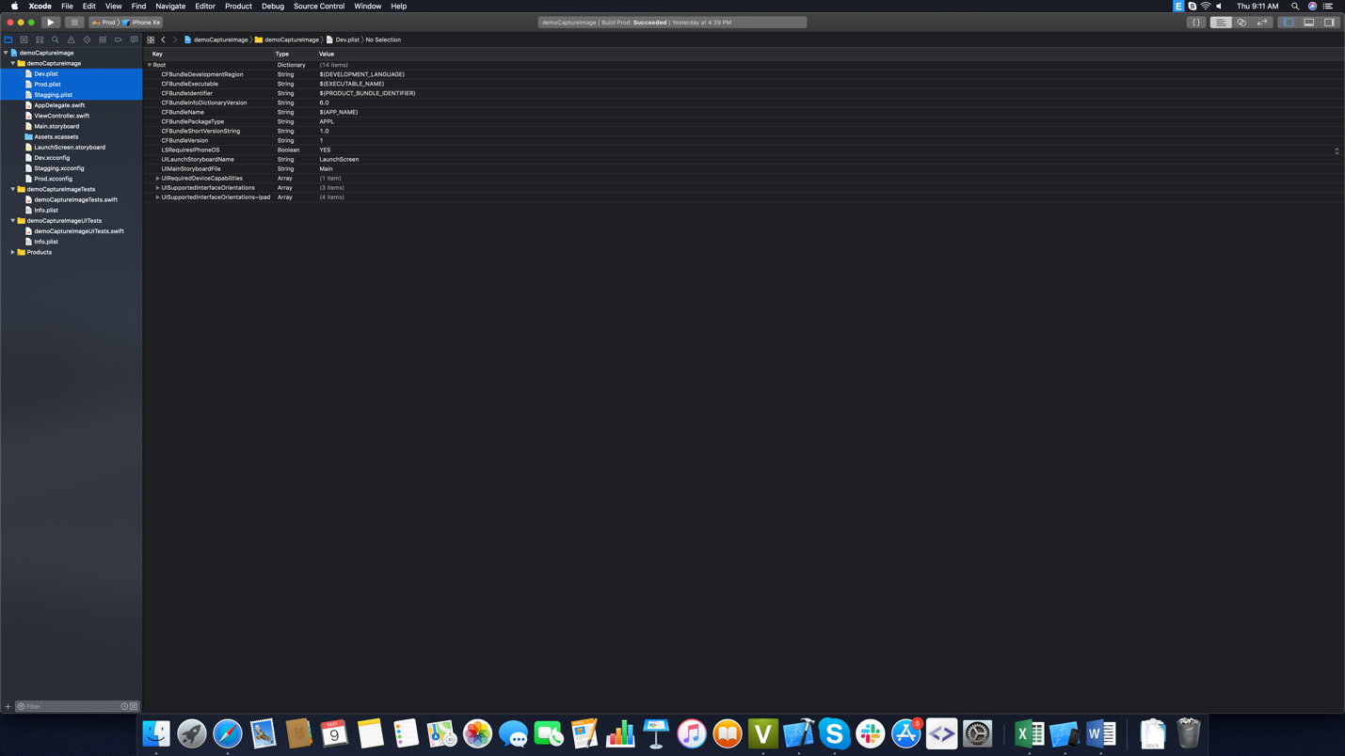

We also have to set the appropriate plist path for each **build configuration**.From **Targets**, just select a plist file and then rename it with the same name for the **Debug** and **Release** configuration.

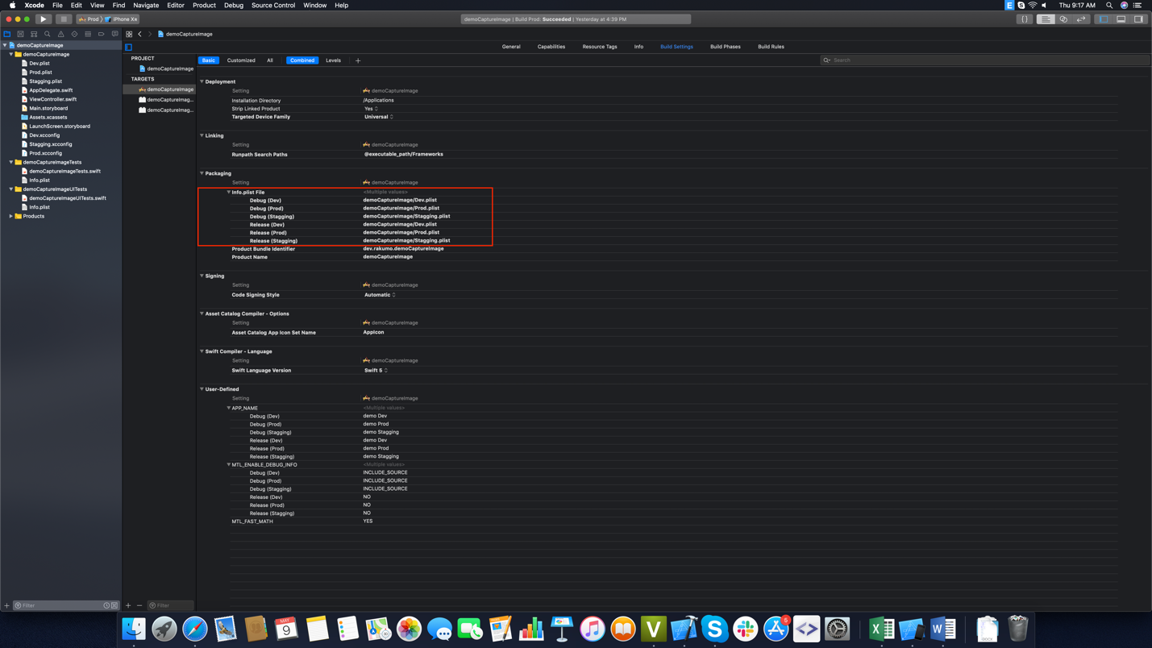

## Link build configuration with the configuration file:

In **Projects Info** we need to set the appropriate configuration file for each build configurations one by one.

After adding all the configuration files, your **Build settings** should look like this:

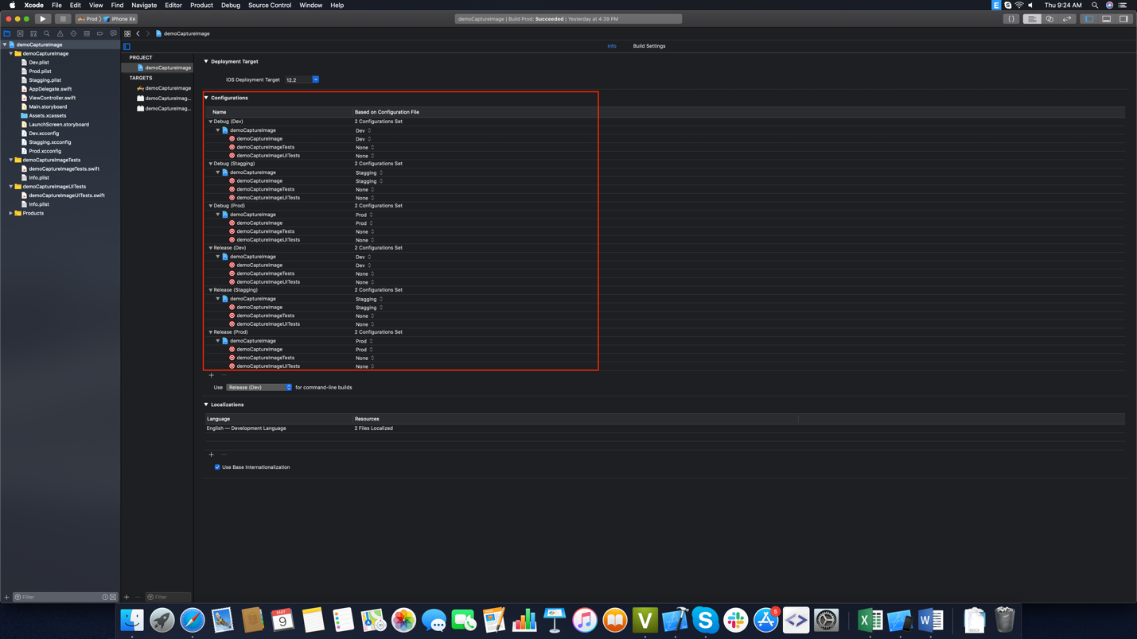

So now we have successfully linked all the configuration files to our build configurations.

## Link schema with the build configuration:

We need to **select each shema** > **edit shema** > **set the appropriate build configuration** here

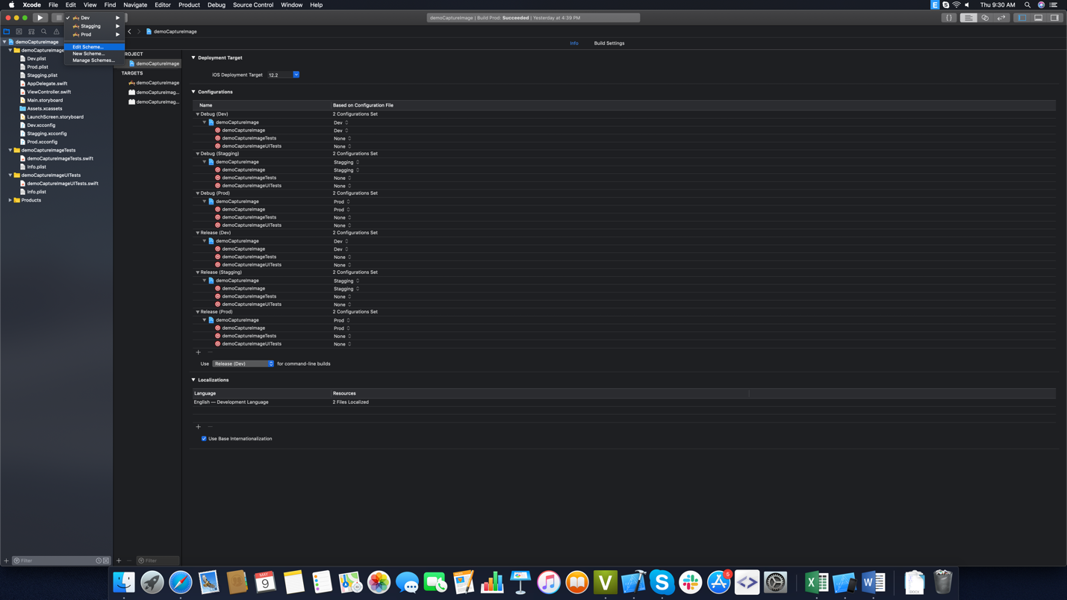

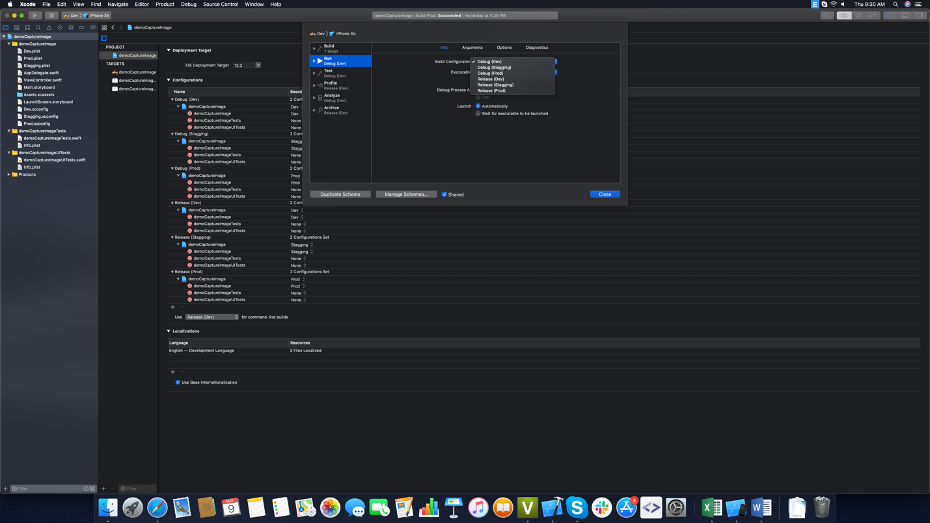

## Config app’s name for each environment:

We need to open each configurations file then define **“APP_NAME”** key with value name same as each environment’s name.

* **Dev: demo Dev.**
* **Stagging: demo Stagging.**
* **Prod: demo Prod.**

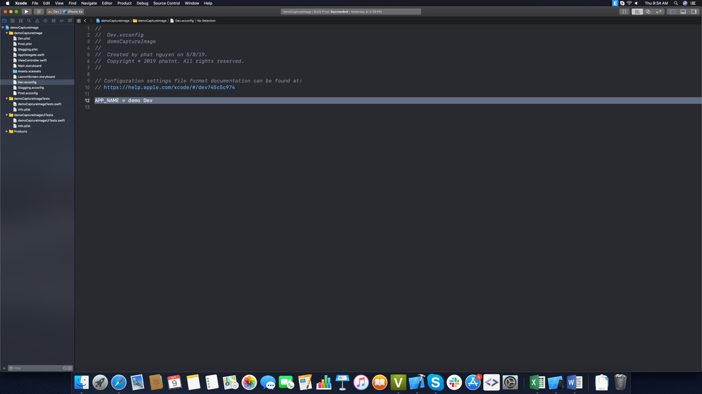

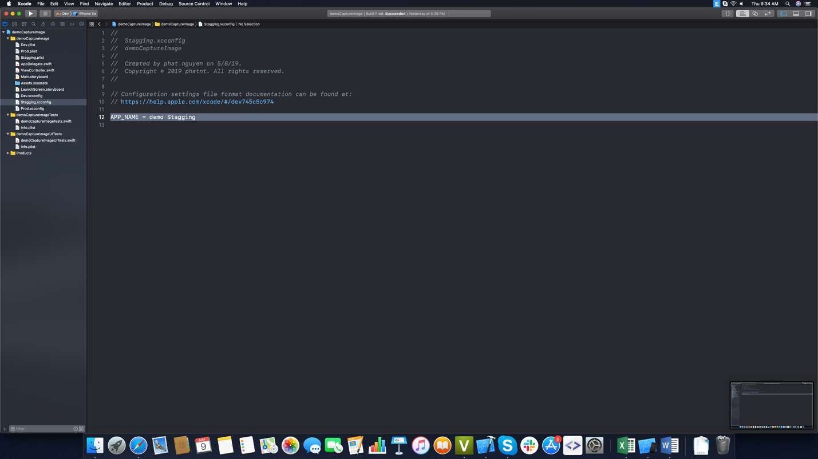

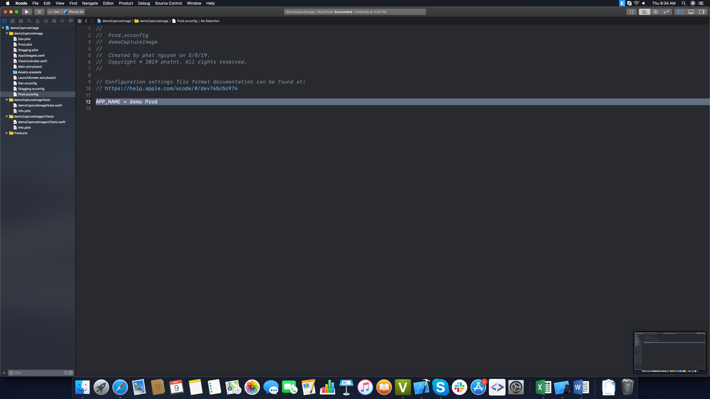

Then we need to open **Info.plist** file then edit **“CFBundleName” key** with value **“$(APP_NAME)”**

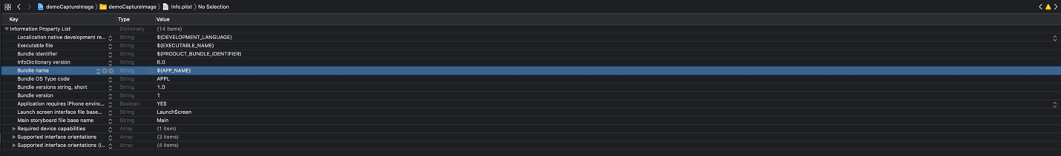

## Build and run project:

After running project we can see app has different name for each selected shema.

* Environment **Dev**:

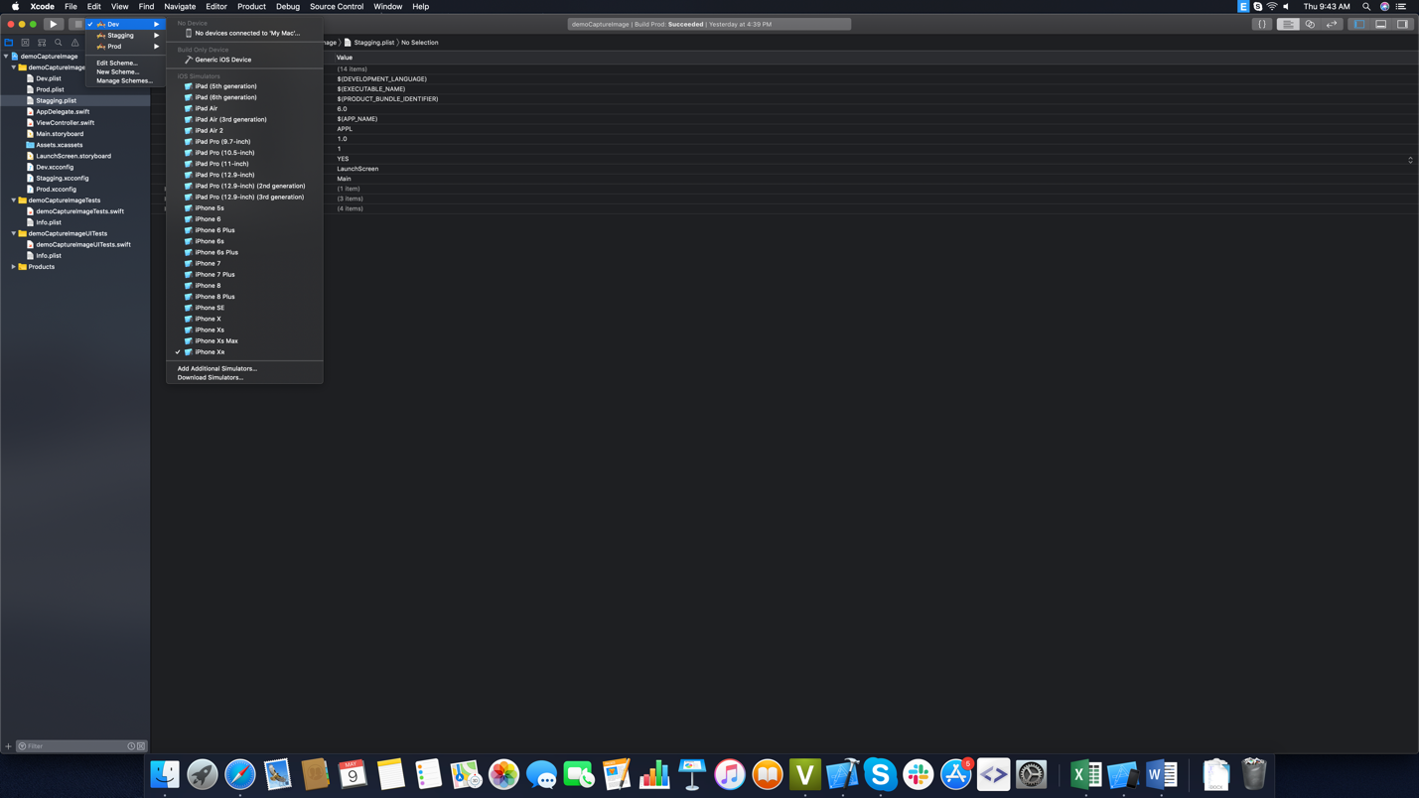

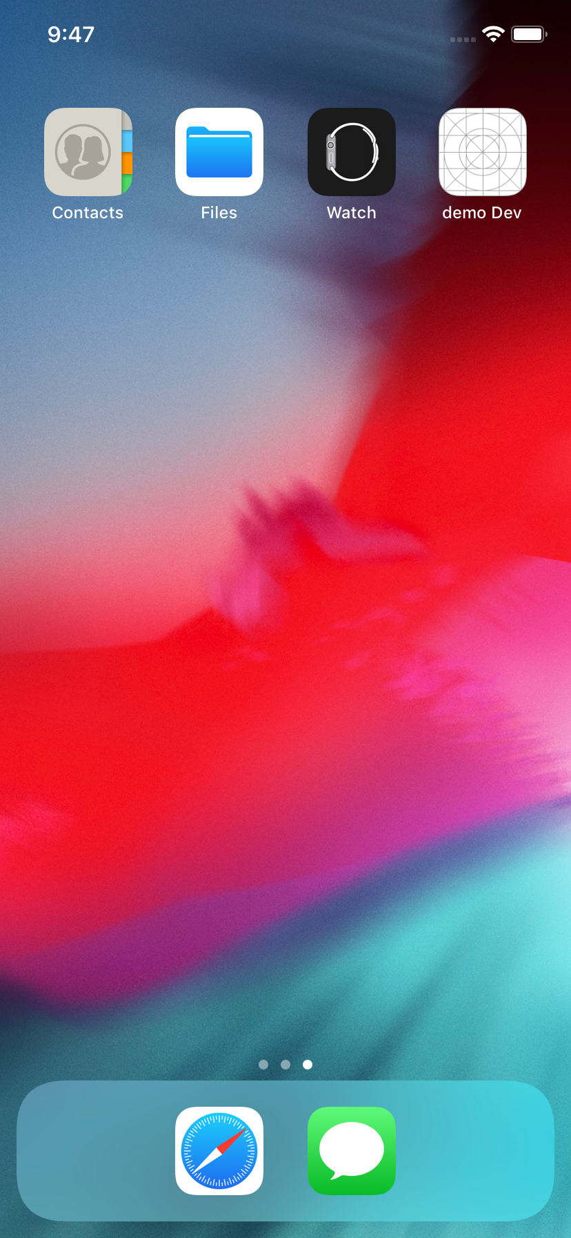

* Environment **Stagging**:

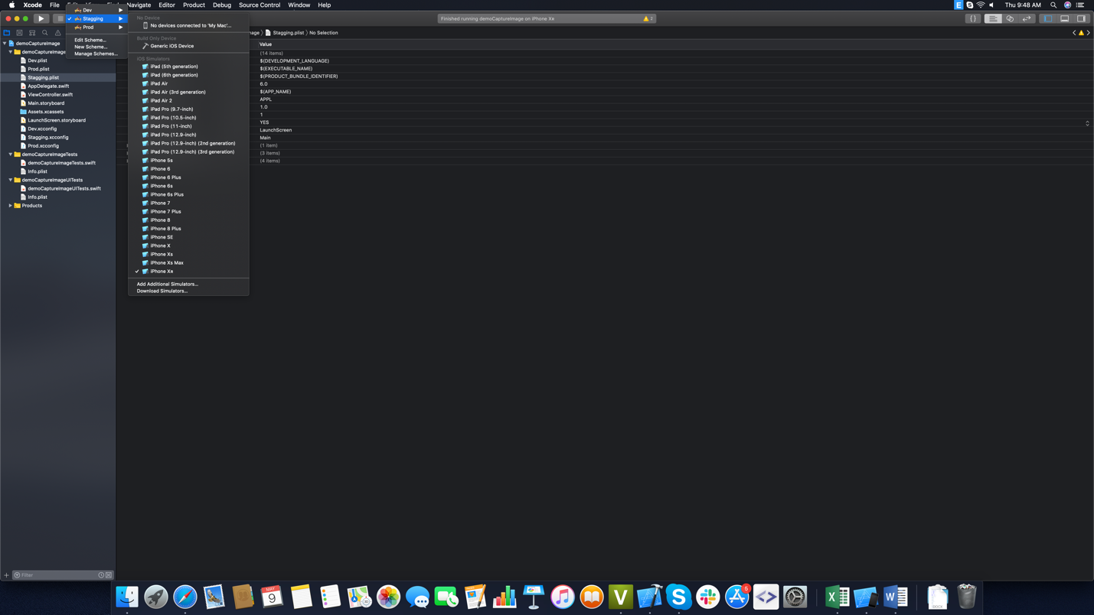

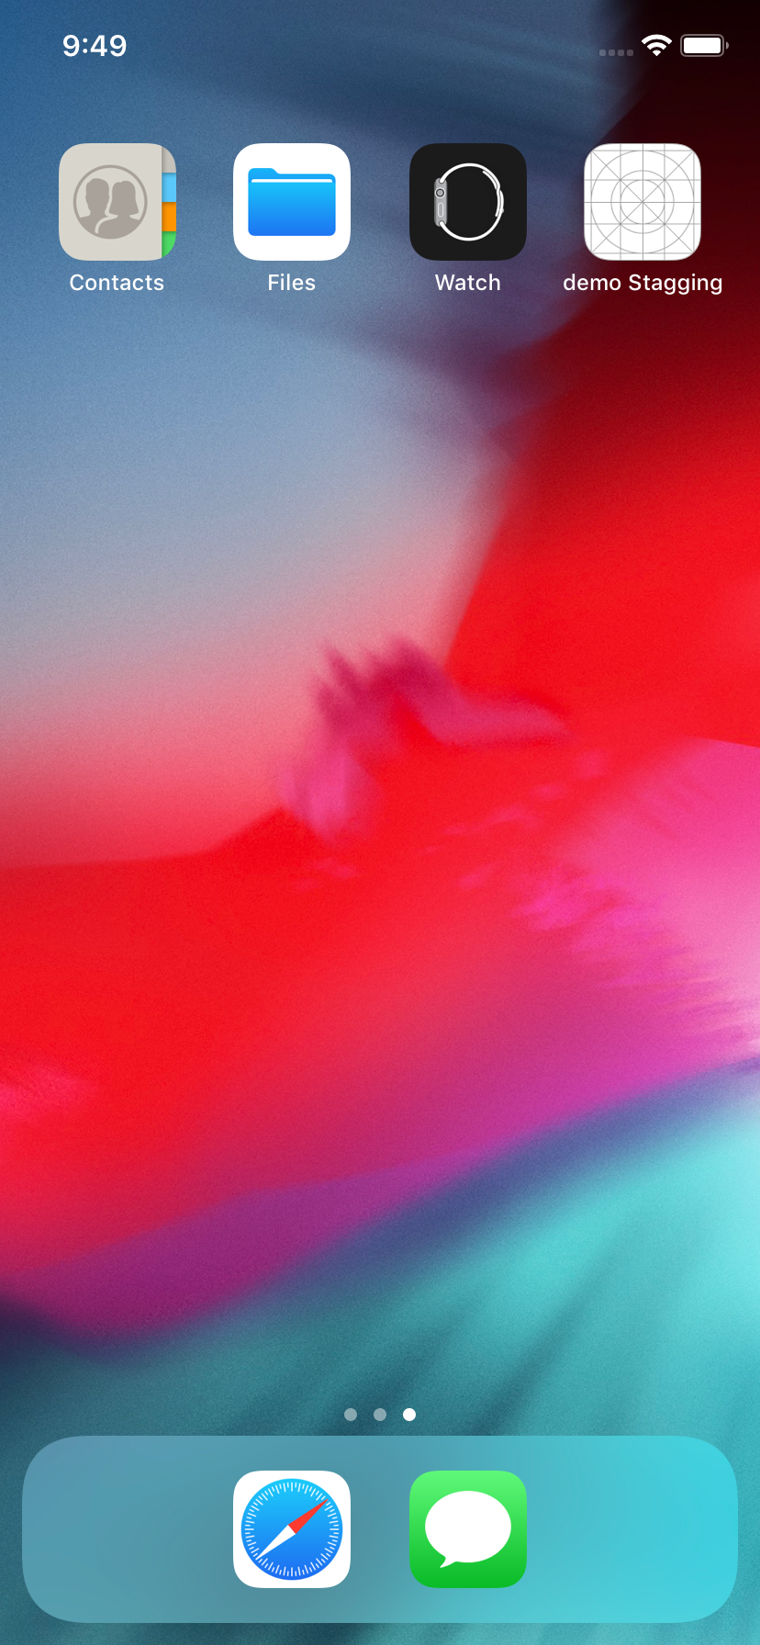

* Environment **Prod**:

